Restoring Waste Places last modified 6/11/2024

Isa 52: 9 Break forth into joy, sing together, you waste places of Jerusalem: for the Lord has
comforted his people KJV my edit Rem also: Handles’s Messiah Is 40
NLT Jer 31: 21 Set up for yourself road signs, place for yourself guideposts;
Direct your mind to the highway, the way by which you went (in other words - when you left His way).
Return, O virgin of Israel... -
Hosea 6: 1 “Come, let us return to the LORD. For He has torn us, but He will heal us;
He has wounded us, but He will bandage us. (song: The Table)
See also “The Wick” - my doc
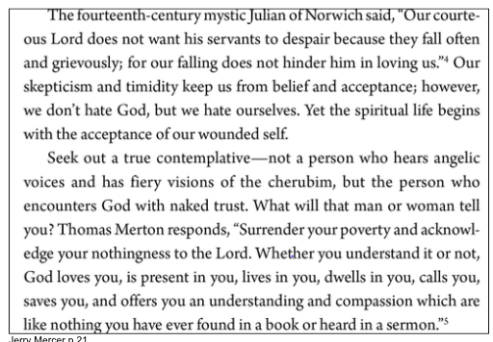
Jerry Mercer p 21
Eph 4: 22 lay aside the old man in reference to your former manner of life, which is being corrupted in
accordance with the lusts of deceit, 23 and that you be renewed in the spirit of your mind,
24 and put on the new man which in the likeness of God has been created in righteousness and
holiness of the truth.
Amp v. 23 And be constantly renewed in the spirit of your mind [having a fresh…mental and spiritual
attitude],
From The Purpose Driven Life
p31 &quot;If you have felt hopeless, hold on! Wonderful changes are going to happen in your life...
Jer 29:11 &quot; I know what I am planning for you. I have good plans for you, not...to hurt you.
I will give you a hope and a good future&quot;
Psalm 126 KJV When the LORD turned again the captivity of Zion, we were like them that dream.
2 Then was our mouth filled with laughter, and our tongue with singing: then said they among the
heathen,
The LORD hath done great things for them. 3 The LORD hath done great things for us; whereof we are
glad. 4 Turn again our captivity, O LORD, as the streams in the south. 5 They that sow in tears shall reap

in joy. 6 He that goeth forth and weepeth, bearing precious seed, shall doubtless come again with
rejoicing, bringing his sheaves with him.
Heb 4: 16 Therefore let us draw near with confidence (boldly, openly) to the throne of grace, so that we
may receive mercy and find grace to help in time of need.
NLT Heb 10:19 And so, ... we can boldly enter heaven’s Most Holy Place because of the blood of
Jesus.
20 By his death, Jesus opened a new and life-giving way through the curtain into the Most Holy Place.
22 let us go right into the presence of God with sincere hearts fully trusting him. For our guilty
consciences have been sprinkled with Christ’s blood to make us clean, and our bodies have been
washed with pure water. 23 Let us hold tightly without wavering to the hope we affirm, for God can be
trusted to keep his promise.
Thoughts:
Gen 13: 1-4 Starting over, course correction, always starts at the place of the altar, the cross or place of
sacrifice.
Heb 12: 2 It is coming back to Jesus He is waiting for us to come to Him
Rom 8: 2 Jesus calls us to live by the higher law, &quot;the law of the Spirit of life in Christ Jesus&quot;
Rom 8: 15 For you have not received a spirit of slavery leading to fear again, but you have
received a spirit of adoption as sons by which we cry out, “Abba! Father!”
When condemnation and confusion prevails, check, listen to your spirit, where the Holy Spirit meets
you.
Heb 10: 1 NLT The old system under the law of Moses was only a shadow, a dim preview of the good
things to come, not the good things (the reality of) themselves. The sacrifices under that system were
repeated again and again, year after year, but they were never able to provide perfect cleansing for
those who came to worship. 2 If they could have provided perfect cleansing, the sacrifices would have
stopped, for the worshipers would have been purified once for all time, and their feelings of guilt
would have disappeared.
3&quot; ...those sacrifices actually reminded them of their sins year after year...it is not possible for the blood
of bulls and goats to take away sins...&quot;
10 &quot;... God’s will was for us to be made holy by the sacrifice of the body of Jesus Christ,
once for all time.&quot;
11 Under the old covenant, the priest stands and ministers before the altar day after day, offering the
same sacrifices again and again, which can never take away sins. 12 But our High Priest offered
himself to God as a single sacrifice for sins, good for all time.
Micah 7: 8 Rejoice not against me, O mine enemy: when I fall, I shall arise when I sit in darkness, the
LORD shall be a light unto me.
The Dream
Hebrews 11 3 All these died in faith, without receiving the promises, but having seen them and having
welcomed them from a distance, and having confessed that they were strangers and exiles on the
earth.
14 For those who say such things make it clear that they are seeking a country of their own.
Thy saints in all this glorious war shall conquer though they die;

they see the triumph from afar,...by faith they bring it nigh Isaac Watts 380 yr ago:

“Shoulders”, by King and country paste the link below into a browser to listen.
https://youtu.be/TfiYWaeAcRw?si=ne39vvTvipf3FyAS&amp;t=1

